Mandatory Template 3: Notification regarding the Board of Management’s review of the Child Safeguarding Statement

To: Le Chéile Schools Trust

The Board of Management of St Louis secondary School Dundalk wishes to inform you that:

• The Board of Management’s annual review of the school’s Child Safeguarding Statement was completed at the Board meeting of 5th April 2022.

• This review was conducted in accordance with the “Checklist for Review of the Child Safeguarding Statement” published on the Department’s ‘website www.education.ie

Signed _____________________________________ Date 5/4/2022

Chairperson, Board of Management
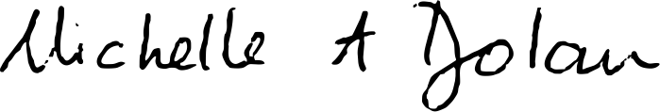

Signed _____________________________________ Date 5/4/2022
Principal/Secretary to the Board of Management

